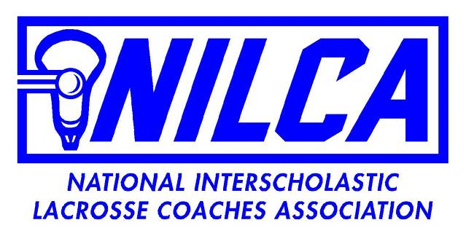

Minutes - General Membership Meeting via Zoom - 2/27/2024

Meeting began 7:30 p.m.

***594 Members as of 2/27/2024—***

Zoom was recorded.

* 1. **Old Business** June 2024 Clinic will not take place - Hartford CC will be notified by end of February; Invited, but not confirmed college coaches will be notified.

a. Need for website content- preferably video….

b. Hall of Fame Dinner - Change of date and venue: New dates - Oct 12, 2024; Oct 18, 2025; Both will be held at the Milleridge Inn, Jericho, NY

* 1. **New Business**

a. Corporate Partners

*1.* ***Scorpion*** *- Performance Wear and Uniforms - 20% discount to members*

*2.* ***LaxBallz*** *- Laser engraved Award Balls - 10% discount to members*

*3.* ***AxiaTime*** *- Hall of Fame Inductee Watches ( going forward); discount to*

*team orders of NILCA members ; order of 20 , the coach receives a*

*free watch.*

b. **Update** on Collaborative NILCA/IMLCA/USALacrosse Clinic- met with: Caitlin Kelly ( USA Senior educational director) and Harry Jacobs ( USA Regional Director) - proposed to have a collaborative Academy with the three organizations in **January 2025** at Chelsea Piers, Stamford CT. The educational committee of the USA Board will appoint a NILCA member to their educational Task Force . A follow-up meeting is planned to formalize protocols / vision within the next two-three weeks.[1]

c. **Call** for additional Corporate Partner contacts: Scorebreak? Lax.com? Wickerssports? Does the membership have specific contacts leadership should enjoin?

d. **Call** for coaching contacts in AZ, California ( northern), Nevada, Texas? Emails or phone numbers ? *Jonathan Adlam ( California) suggested contacting Gabe Fowler and Lynn Poterfield - both regional directors for USA lacrosse with plenty of High school coaches’ contact info*

e. **Need** State Representatives/Chairs - to honor COY, MOY and POY in your respective states; *Jonathan Adlam volunteered for Southern California*. *His offer gratefully accepted.*

f. **General Meetings**: Future general meetings (via Zoom) will be held in Early November, February and Mid June .

Meeting adjourned - 8:05 p.m.

Respectfully, submitted,

JMK

VP - Hall of Fame Chair

1. *USA Lacrosse will require a Task Force application process; the NILCA will solicit nominations from the NILCA membership of those interested and forward the those ‘nominations’ to USA Lacrosse for further completion of their vetting process.*